University of Houston

PRIME – PREDICTOR

A FPGA BASED GAME

Team

Adithya Sekar - 1637408

AnishKumar Chouhan - 1850356

Gokul Venugopal - 1824696

Joy Rebello - 1764719

Naveen Subramanian - 1808626

# **ABSTRACT**

A prediction game is a game which allow users to guess at the outcome of future events. Points are awarded to players who most accurately predict the outcome of an event, and those points are converted into cash prizes. Prediction Games have recently become popular on the internet. Our prediction game is implemented on a FPGA and can be played by multiple authentic users. User can score points by guessing the prime number randomly generated by the FPGA board. However, to make the game more challenging, a fixed timer will be kept running and the range within which random number will be increased as user scores increase. This game also provides feature for user to see the highest score and the user who has scored the highest.

Table of Contents

**ABSTRACT** 2

**INTRODUCTION** 3

**CONCEPT** 5

**MODULES** 8

1. Button Shaper 8

2. Access Controller 11

3. Seven Segment Display 14

4. ADDER 17

5. TimerOneSecond 17

6. TimerLoad 18

7. TimerForEachDigit 19

8. Timer100ms 20

9. Timer1ms 20

10.Timer 21

11.successRounds 22

12.RandomNumberGen 22

13.CountTo100 23

14. CountTo10 23

**System Architecture** 24

**SIMULATION** 28

Access Control 28

Load Register 28

Button Shaper 29

Seven Segment 29

Random Number Generator 29

Timer 30

Timer1ms 31

Count To 100 32

Count To 10 32

successRounds 33

LAB 3 Top Test Module 33

**FPGA TESTING RESULT** 35

**Conclusion** 41

Appendix 41

# **INTRODUCTION**

The idea is to design a gaming system that has the following:

1. An Access Controller module to the system to authenticate the players. For this we are going to use my last four digits of PeopleSoft ID as default password. Then using 4 unused toggle switches and one push button, user can enter the password. After each digit is set on toggle switches (in its binary form), the push button is pushed to enter that digit. After all, 4 digits are successfully entered and verified, the players are allowed to play the game. User authentication status is shown in LED; if authenticated GREEN LED. Otherwise RED LED.
2. Timer based game starts with user entering a time using 8 toggle switches and password button to describe the timer value is seconds. 8 toggle switches are divided into two set; one for unit place and second for ten’s place. When user hit password button, timer value will start and continue to decrease per second until it reaches 0. After user authentication, user need to set timer value using toggle switch and then hit password button to enter the timer value and then user can start game.
3. To enhance the game experience, one of the inputs will be generated by a random generator. A push button is allocated to generate a random number and its value will be equal to the duration button is pressed. Then the player will set the 4-bit number using toggle switches, and then push a button to load the number into the system. Before the load button is pushed, any intermediate changes to the toggle switch settings will not be displayed or used by the system for computation. Player will have his own push button to enter the input. The number entered by Player will be loaded to the system if the corresponding LOAD button is pushed. User can continue doing this until timer value reaches 0.
4. These input along with their sum will be displayed. If sum is 15 then GREEN LED will glow otherwise RED LED will glow.
5. When player can make sum as 15, a score counter is incremented. Max score is 99 and is shown using two different seven segment displays.
6. Since there is a RESET button. The RESET signal will be wired to all sequential modules directly. Except for the RESET button, all button signals will be processed first by a button shaper module to convert a long low pulse to a single cycle high pulse when a button is pushed.
7. User can reset the timer after its value reaches 0, by pressing the same password button and start timer by pressing again. Then user will be able to re-enter values and play again. Once timer reaches 0, input changes will not be shown in display. Also, before the game is authenticated, Player cannot load the number or generate random number even if the LOAD button/random number generator button is pushed.
8. When timer reaches 0, a timeout is shown by lighting RED led and ‘F’ is shown in display to resemble game finished.

How to Play:

1. One player is required to play the game.
2. First step is to authenticate user. For this user, must input a 4-digit password to the system. User need to enter digit by digit in its binary form using the 4-toggle switch.
3. If user is authenticated, then a green LED will glow. Otherwise a RED LED.
4. If user is authenticated, player need to enter a duration is seconds using toggle switch and password button to start the game.
5. Timer value need to entered first, only then player can generate a random number using a push button and enter his input using another set of 4 toggle switch and another push button.
6. Player first presses random number generator button to generate a random number according to the time button is pressed. Then player can input his value. He must enter an input so that sum is 15. If player has selected such an input, then GREEN led will glow otherwise RED led. Also, score will be incremented by one and displayed. If user score reaches 99, then score value will restart from 0.
7. User can regenerate a random number and load his value if timer is not 0. Timer value will continue to decrease per second. Once timer reaches 0, player cannot play game. He must reset timer pressing password twice. If he presses password button, then timer value is reset and then he can play.
8. When timer reaches 0, user is logged out of game. Logout action is show by GREEN led turning off, timeout LED is lit and ‘F’ is shown in display. During this phase, players cannot add new values, but their previous value will be retained.
9. User can log in by re-setting timer by pressing password button.
10. If user is not authorized on step 2, then another RED led will glow. To reenter into the system, user need to press reset button.

# **CONCEPT**

The system is designed to allow a player to enter input according to a random number generated and their sum will be displayed along with respective LED indicator. The players can only enter inputs if they are authenticated and timer is running. Player score is also displayed. For this activity, following inputs are variables are used:

|  |  |  |  |
| --- | --- | --- | --- |
| SL No: | Parameter Name | Type of Parameter | Description |
|  | Password | Input | It is 4-bit input variable that defines each password digit. |
|  | player1_button_input | Input | A 4bit input variable that is used to load random number generator. |
|  | player2_input | Input | A 4-bit input variable used to get input value of player 2. |
|  | player2_button_input | Input | A push button input that reads player 1 input from toggle switches that is stored in load_player1_inp |
|  | timeout | Output | An output value that indicates if timer has reached 0 or not. If timeout is 1, then timer value is 0. |
|  | password_button_input | Input | A push button input that reads player 2 input from toggle switches that is stored in load_player2_inp |
|  | access_flag_allow | Output | Defines the led that glows when user is authenticated |
|  | access_flag_denied | Output | Defines the led that glows when user is not authenticated. It also resembles when timer value reaches 0 if user was authenticated first. |
|  | sum_green | Output | Defines the led that glows when sum of user input is 15 |
|  | Sum_red | Output | Defines the led that glows when sum of user input is not equal to 15 |
|  | Sum_disp | Output | Used to display the sum of two player inputs on a 7-segment display |
|  | player1_output_disp | Output | Used to display the player 1 input on a 7-segment display |
|  | player2_output_load_disp | Output | Used to display the player 2 input on a 7-segment display |
|  | Password_disp | Output | Used to display the password digit entered by user. |
|  | Rst | Input | Resets the whole system when this button is pressed |
|  | Clk | Input | Defines the clock for the circuit |
|  | timer_ten_input | Input | Used to input the ten’s digit of the timer value using toggle switch. |
|  | timer_unit_input | Input | Used to input the unit’s digit of the timer value using toggle switch |
|  | timer_output_digit_unit_disp | Output | Used to display unit digit of the timer in a 7-segment display |
|  | timer_output_digit_tens_disp | Output | Used to display tens digit of the timer is a 7-segment display |
|  | totalPoints_ten_disp | Output | Used to display tens digit of the user score is a 7-segment display |
|  | totalPoints_unit_disp | Output | Used to display unit digit of the user score is a 7-segment display |

Figure 1: Parameter Mapping Table

Random Number Generator

password display

Timer

two 4bit input : player display

Player random number

4bit input display

Sum LED

Verilog Code

Password

(4 digits) sum display

Clk

Reset Access LED

Player1 load

Button timeout

Player 2 load

Button password

matched LED

Password input/ user score

Timer button

Figure 2: Symbol of game system

# **MODULES**

## 1. Button Shaper

Button Shaper module will be designed using a sequential circuit to switch between states. There are three states in this system.

|  |  |
| --- | --- |
| **State** | **Description** |
| INIT | This is the default state when button is not pressed, and output remain low. |
| PULSE | This is the state of the system when button is pressed. The output value will go high in the next clock cycle |
| WAIT | System will be in this state when button is pressed and remains in this state if button is pressed. Once button is released state goes to INIT |

When button is pressed, the system moves from the initial state INIT to PULSE state with output value going from low to high. The output value is reflected in the next clock cycle and remains high only for one clock cycle. After that it goes low until button is pressed next time. System remains in WAIT state until the button is released. Once button is released, system goes to INIT state.

|  |  |  |  |
| --- | --- | --- | --- |
| **SL No:** | **Parameter Name** | **Type of Parameter** | **Description** |
| 1 | Button_input | Input | Defines the action of a button. It goes low when button is pressed and remains high when button Is not selected |
| 2 | Clk | Input | Defines the clock signal for the sequential circuit. |
| 3 | Rst | Input | Defines reset signal which would reset the state to INIT when it is low. |
| 4 | result | output | Defines the result that goes high for one cycle when button is pressed and released. |
| 5 | Current_state | Register | Defines the current state of the system. |
| 6 | Next_state | Register | Defines the next state of the system |

Figure 3: Parameter Mapping Table

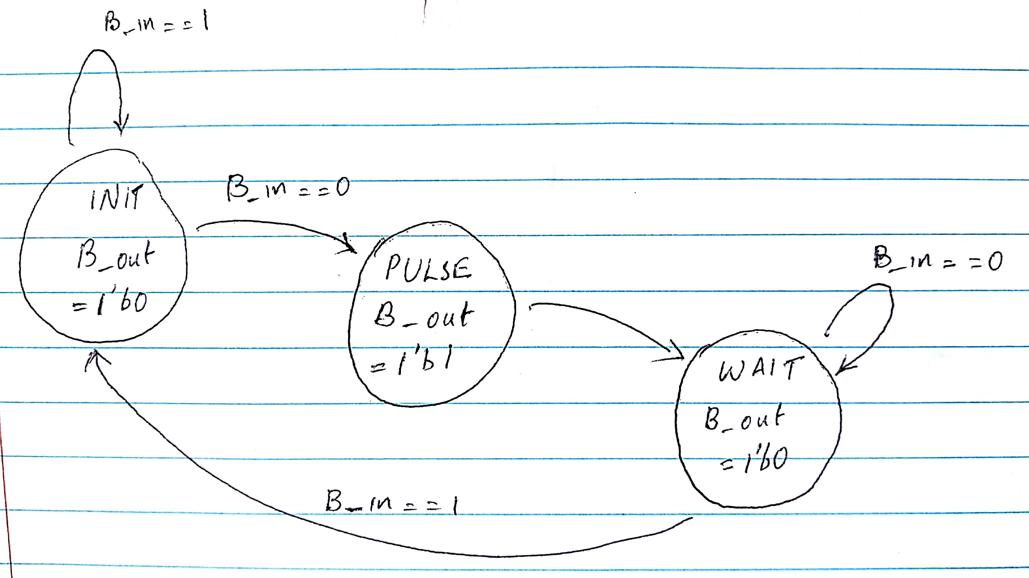

Figure 4: FSM for Button Shaper

button_input

buttonShaper() module

rst result

clk

Figure 5: Block Diagram

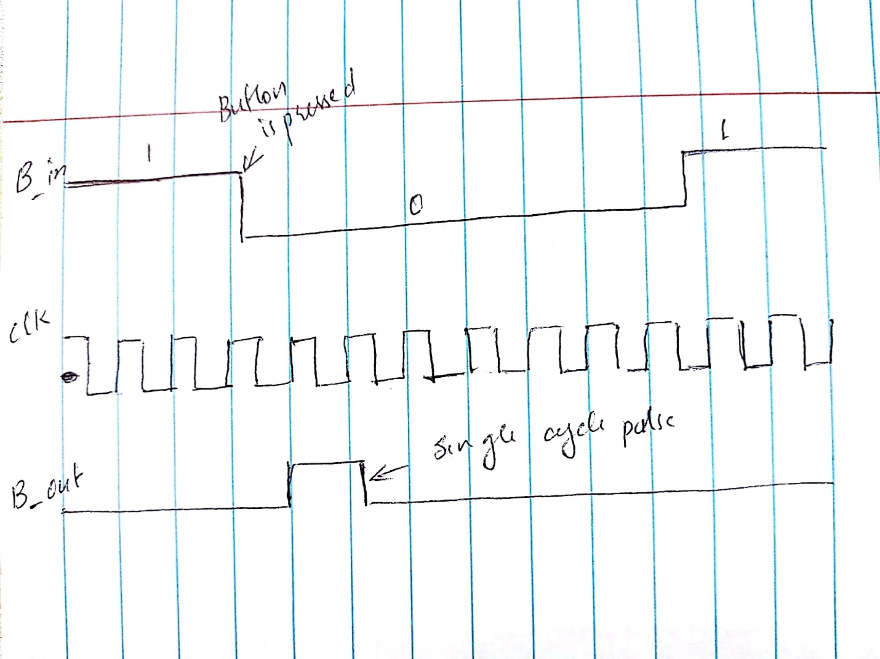

Figure 6: Expected behavior of a button shaper

## 2. Access Controller

Access Controller module will be designed using a sequential circuit to authenticate user. There are five states in this system.

|  |  |
| --- | --- |
| **State** | **Description** |
| INIT | This is the default state when button is not pressed, and output remain low. It then checks the first digit of stored password and moves to DIGIT1. Initial value of check_flag = 1. If comparison does not match, check_flag = 0. |
| DIGIT1 | System reach this state if value stored in password to be compared against 1st digit gives positive result. It then checks the second digit of stored password and moves to DIGIT2. If comparison does not match, check_flag = 0. |
| DIGIT2 | System reach this state if value stored in password to be compared against 2nd digit gives positive result. It then checks the third digit of stored password and moves to DIGIT3. If comparison does not match, check_flag = 0. |
| DIGIT3 | System reach this state if value stored in password to be compared against 3rd digit gives positive result. It then checks the fourth digit of stored password and moves to FINAL. If comparison does not match, check_flag = 0. |
| FINAL | System reaches this state from any of the previous state. It checks value of check_flag to decide whether lit up green/red led. It also acts as a stage to load timer value by pressing password button again. It also serves as a comeback state after timeout happens and then user can reset the timer value. |
| TIMER | System reaches this stage when user is authenticated and has set timer value. Systems continues in this state loading player and random number value until timer hits 0. Once timer hits 0, then system goes back to state FINAL. |

When button is pressed, the system accepts the input password digit and checks with the respective digit stored. If comparison matches it moves forward to next state. In all states, password is compared against stored value and check_flag is set accordingly.

|  |  |  |  |
| --- | --- | --- | --- |
| **SL No:** | **Parameter Name** | **Type of Parameter** | **Description** |
| 1 | Button_input | Input | Defines the action of a button. It goes low when button is pressed and remains high when button Is not selected |
| 2 | Clk | Input | Defines the clock signal for the sequential circuit. |
| 3 | Rst | Input | Defines reset signal which would reset the state to INIT when it is low. |
| 4 | Password | Input | Defines each digit of the 4 digit password. |
| 5 | Current_state | Register | Defines the current state of the system. |
| 6 | Load_player1_inp | Input | Defines the load value of player 1 that will be shown in output if password matches. |
| 7 | Load_player2_inp | Input | Defines the load value of player 2 that will be shown in output if password matches. |
| 8 | Load_player1_out | Output | Defines the output load value of player 1 that will be show load_player1_inp as output if password matches. Otherwise it is zero. |
| 9 | Load_player2_out | Output | Defines the output load value of player 2 that will be show load_player2_inp as output if password matches. Otherwise it is zero. |
| 10 | Timeout | Input | Indicates whether timer hit 0 or not. |
| 11 | Access_flag_allow | Output | Represents green led that goes high when password match |
| 12 | Access_flag_allow | Output | Represents red led that goes high when password does not match |
| 13 | timer_tens_input | Input | Defines tens place of the timer value |
| 14 | timer_unit_input | Input | Defines unit place of the timer value that user enter. |
| 15 | timer_tens_output | Output | Defines a load register that stores the input value if user is authorized |
| 16 | timer_unit_output | Output | Defines a load register that stores the input timer unit place if user is authorized. |

Figure 7: Parameter Mapping Table

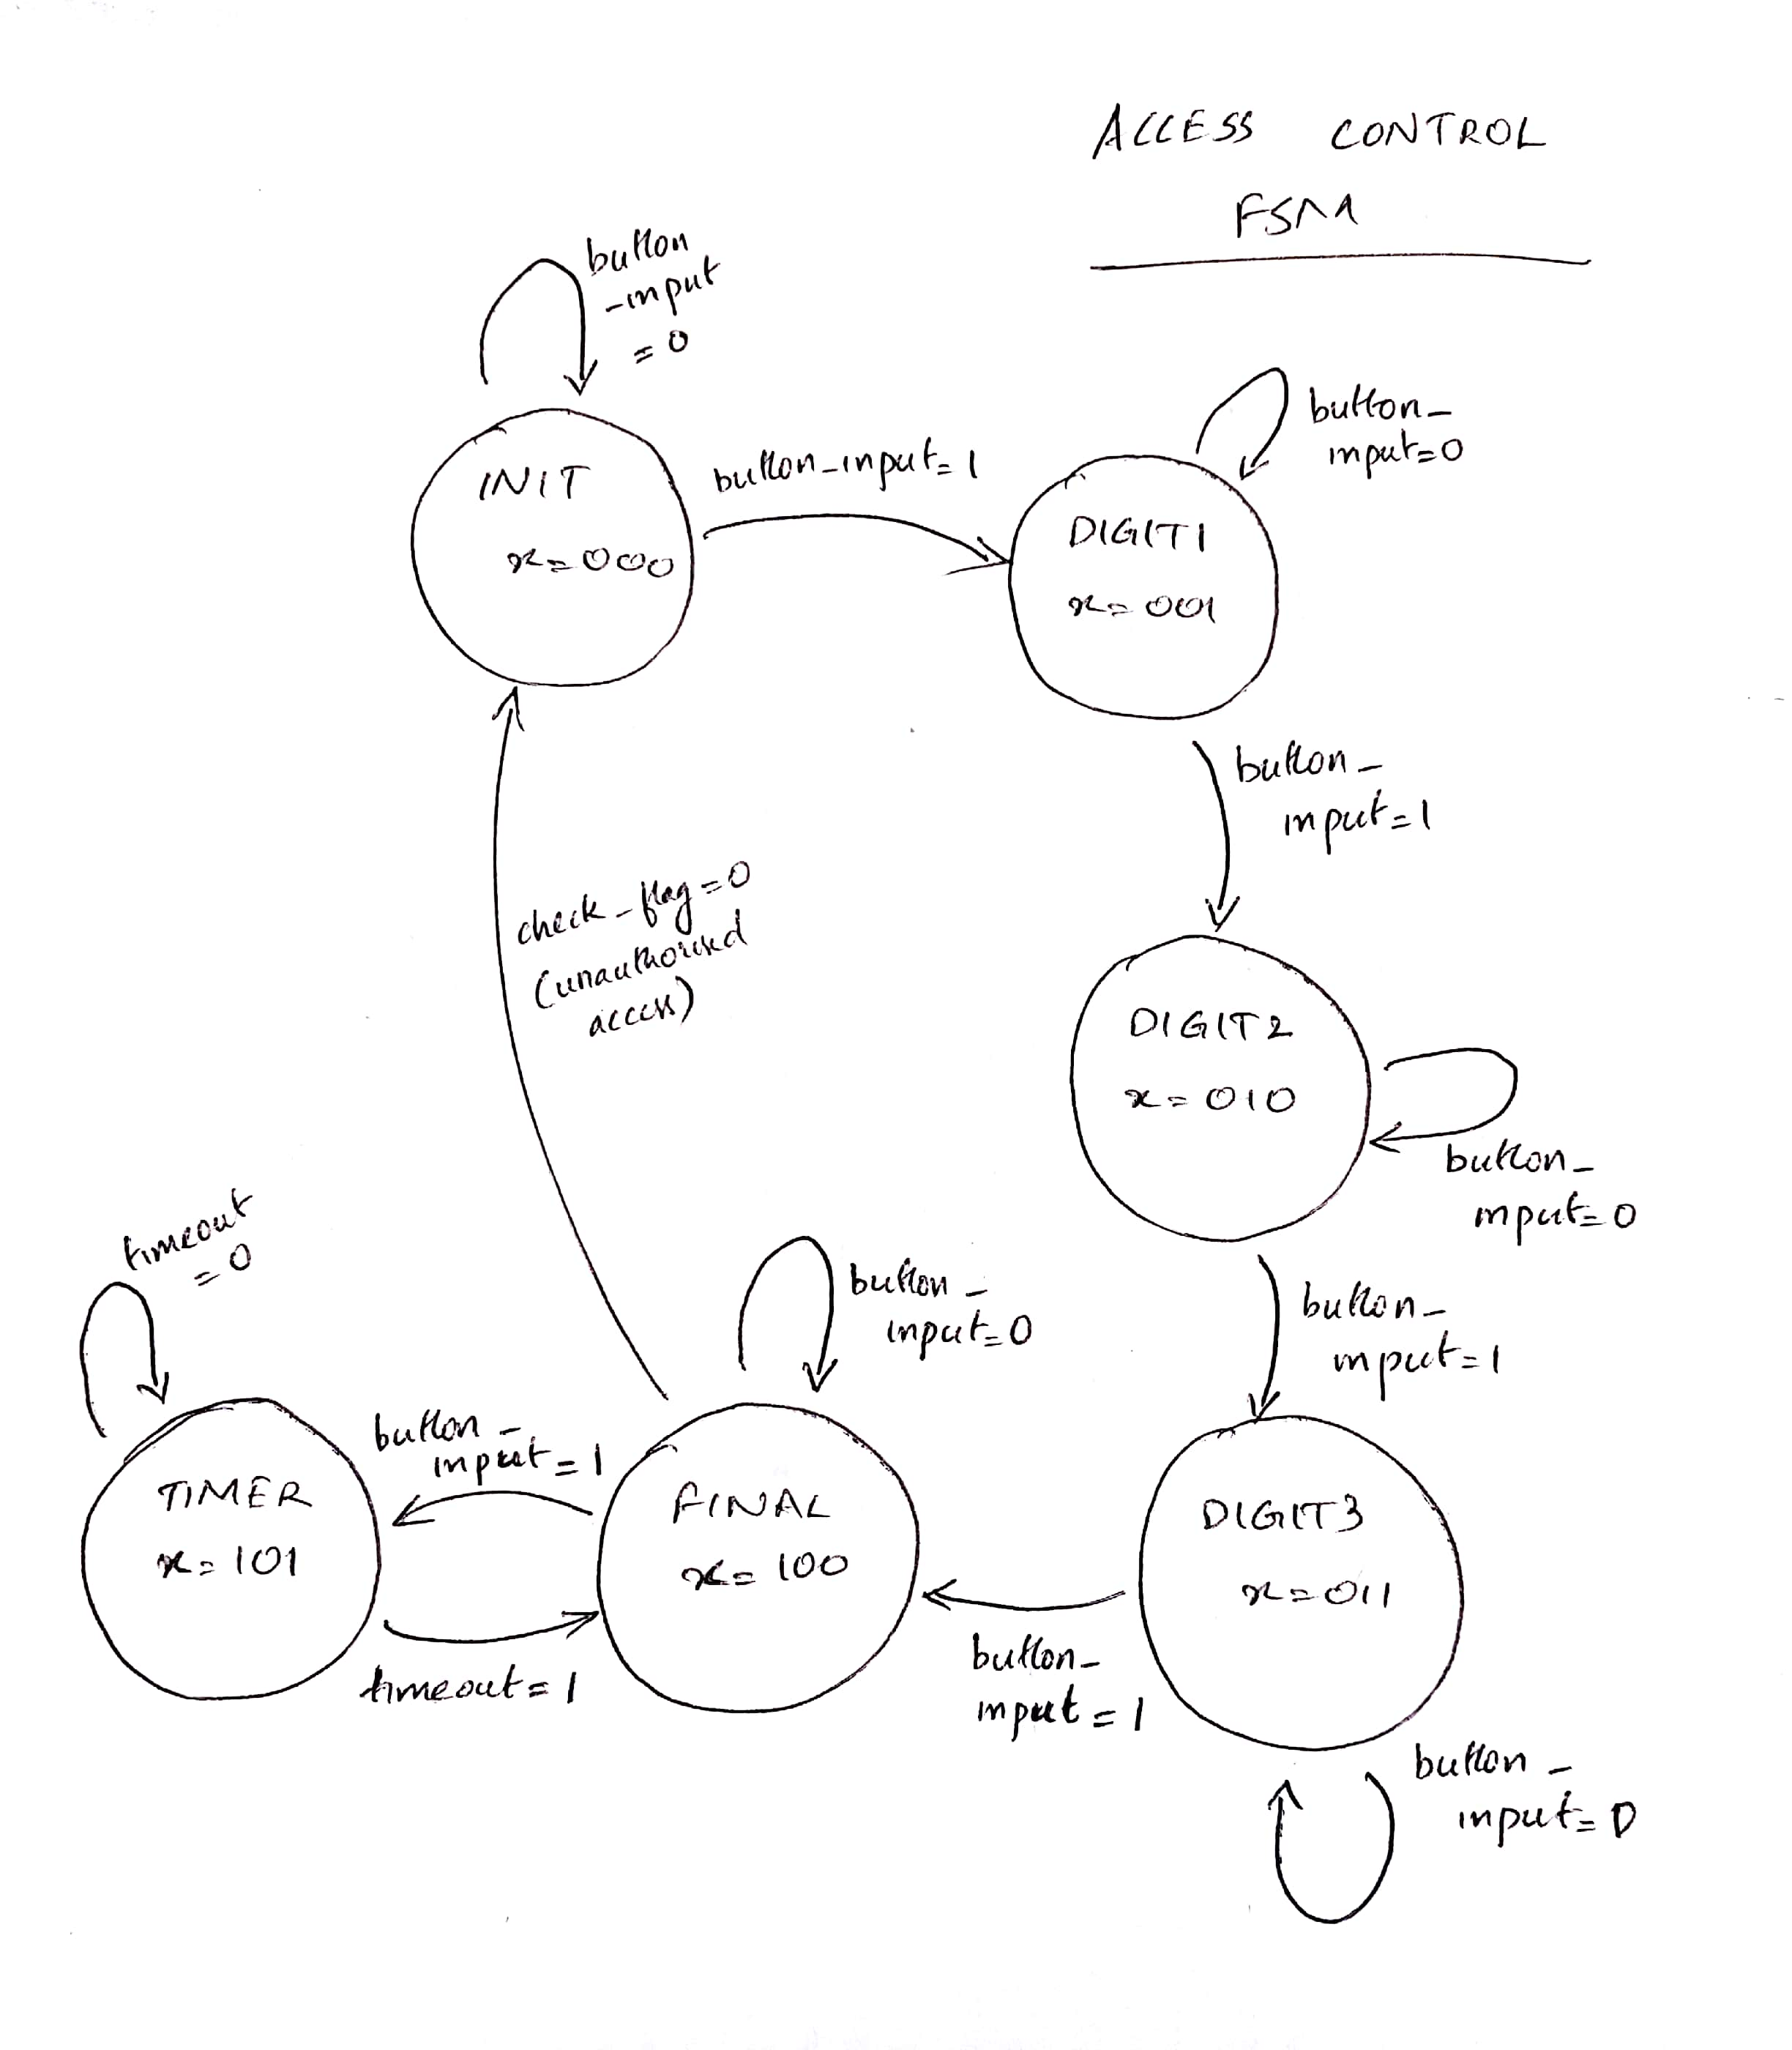

Figure 8: FSM for access control

Access_control

password

button_input access_flag_allow

timeout access_flag_denied

load_player1_inp load_player1_out

clk load_player2_out

rst timer_unit_output

load_player2_inp timer_tens_output

timer_unit_input

timer_tens_input

Figure 9: Symbol Diagram

## 3. Seven Segment Display

In this module, we are taking 4-bit input and using Verilog, we would generate necessary 7 bit output. 7-segment display has 7 segments that are resembled by 1 bit and is active low. i.e. segment will glow if output bit is 0 and will be off is output bit is 1.

|  |  |  |  |
| --- | --- | --- | --- |
| SL No: | Parameter Name | Type of Parameter | Description |
| 1 | Decoder_in | Input | Defines the input number which would be displayed over 7 segment display. Number can range from 0 – 15 – represented by 4 bits. |
| 2 | Decoder_out | Output | Defines the output bit that would be used to display each segment of the display. The output is of 7 bit. |

Figure 10: Parameter Mapping Table

4 bit

input

Verilog Code

To seven segment

Display

(7 bit output)

Figure 11: Block Diagram

|  |  |  |  |  |  |  |  |  |  |  |  |
| --- | --- | --- | --- | --- | --- | --- | --- | --- | --- | --- | --- |
| **Number** | **Inp3** | **Inp2** | **Inp1** | **Inp0** | **Out6** | **Out5** | **Out4** | **Out3** | **Out2** | **Out1** | **Out0** |
| 0 | 0 | 0 | 0 | 0 | 1 | 0 | 0 | 0 | 0 | 0 | 0 |
| 1 | 0 | 0 | 0 | 1 | 1 | 1 | 1 | 1 | 0 | 0 | 1 |
| 2 | 0 | 0 | 1 | 0 | 0 | 1 | 0 | 0 | 1 | 0 | 0 |
| 3 | 0 | 0 | 1 | 1 | 0 | 1 | 1 | 0 | 0 | 0 | 0 |
| 4 | 0 | 1 | 0 | 0 | 0 | 0 | 0 | 1 | 1 | 0 | 1 |
| 5 | 0 | 1 | 0 | 1 | 0 | 0 | 1 | 0 | 0 | 1 | 0 |
| 6 | 0 | 1 | 1 | 0 | 0 | 0 | 0 | 0 | 0 | 1 | 0 |
| 7 | 0 | 1 | 1 | 1 | 1 | 1 | 1 | 1 | 0 | 0 | 0 |
| 8 | 1 | 0 | 0 | 0 | 0 | 0 | 0 | 0 | 0 | 0 | 0 |
| 9 | 1 | 0 | 0 | 1 | 0 | 0 | 1 | 1 | 0 | 0 | 0 |
| 10 | 1 | 0 | 1 | 0 | 0 | 1 | 0 | 0 | 0 | 0 | 0 |
| 11 | 1 | 0 | 1 | 1 | 0 | 0 | 0 | 0 | 0 | 1 | 1 |
| 12 | 1 | 1 | 0 | 0 | 1 | 1 | 1 | 0 | 0 | 0 | 0 |
| 13 | 1 | 1 | 0 | 1 | 0 | 1 | 0 | 0 | 0 | 0 | 1 |
| 14 | 1 | 1 | 1 | 0 | 0 | 0 | 0 | 0 | 1 | 0 | 0 |
| 15 | 1 | 1 | 1 | 1 | 0 | 0 | 0 | 1 | 1 | 1 | 0 |
| Other case |  |  |  |  | 1 | 1 | 1 | 1 | 1 | 1 | 1 |

Figure 12: Truth Table

## 4. ADDER

This module is used to add two inputs. If the sum is 15 then if green LED output is set HIGH otherwise RED LED is set HIGH. It also gives out sum as an output.

Figure 13: Adder block diagram

Adder Logic

player1 input sum

player 2 input Green LED output

RED LED output

|  |  |  |  |
| --- | --- | --- | --- |
| **SL no:** | **Names** | **Type** | **Description** |
| 1 | Player1 input | Input | A 4bit input for player1 |
| 2 | Player2 input | Input | A 4bit input for player 2 |
| 3. | Sum | Output | A 4bit variable to store sum |
| 4. | Green Led output | Output | A 1bit value that goes high when sum is 15 |
| 5. | Red LED output | Output | A 1bit value that goes high when sum is not 15 |

Figure 14: Parameter Description

## 5. TimerOneSecond

This is timer one second module. It internally calls 100ms counter 10 times and gives out timeout when it is called 10 times.

timer1ms_enable

Figure 15: TimerOneSecond block diagram

TimerOneSecond

clk countTo10_timeout

rst

|  |  |  |  |
| --- | --- | --- | --- |
| **SL no:** | **Names** | **Type** | **Description** |
| 1 | Timer1ms_enable | Input | A 1bit enable signal that is used to start the timer |
| 2 | Clk | Input | Clock signal |
| 3 | Rst | Input | A reset button that resets everything |
| 4 | countTo10_timeout | Output | A single bit output that goes high when timer reaches 1 second |

Figure 16: Parameters description

## 6. TimerLoad

This module is used to load timer value flag if user is authenticated and the password button is pressed after. This is to ensure timer value is not inserted before user is authenticated and password button is pressed again.

Figure 17: TimerLoad block

TimerLoad

Timer_button

Access_allow timer_load

clk

rst

|  |  |  |  |
| --- | --- | --- | --- |
| **SL no:** | **Name** | **Type** | **Description** |
| 1 | Timer_button | Input | A button that goes low when is pushed |
| 2 | Access_allow | Input | A single bit input that says whether user is authenticated or not |
| 3 | Clk | Input | Clock signal |
| 4 | Reset | Input | Reset button |

Figure 18: Parameter description

## 7. TimerForEachDigit

This module is to act as a countdown timer for each digit. It would start decrementing according to the start/stop value coming from Timer module. Once timer reaches 0 it raises a timeout flag. Timer is created in a way that when it reaches 0, it would check if it can borrow from higher digit by raising need_to_borrow flag, if it can, it would recieve can_borrow flag as 1. can_borrow recieve value from can_give of the higher digit module. To set can_give of higher digit module, higher module would check if it is recieving asking_borrow flag as 1. If lower digit module recieve can_borrow as 1, then digit value is set to 9 and continues decrementing. Finally, it is not recieving can_borrow as 1, then timeout flag is set 1.

Figure 19: TimerForEachDigit block diagram

TimerForEachDigit

Timer_input_digit

can_borrow timer_output_digit

asking_borrow need_to_borrow

start timeout

clk can_give

rst stop

|  |  |  |  |
| --- | --- | --- | --- |
| **Sl no:** | **Name** | **Type of parameter** | **Description** |
| 1. | Timer_input_digit | Input | A 4bit number that denotes one digit of the timer. |
| 2. | Can_borrow | Input | A 1 bit number that goes high if higher digit can donate a borrow. |
| 3. | Asking_borrow | Input | A 1bit number that resemble if lower digit needs to borrow from higher digit |
| 4. | Start | Input | A 1bit number that defines whether a timer need to start or not |
| 5. | Timer_output_digit | Output | A 4bit number that denotes the timer value. This decreases till it reaches 0. |
| 6. | Need_to_borrow | Output | A 1bit number that tells whether lower digit need to borrow from higher digit. |
| 7. | Timeout | Output | A 1bit number that goes high for one cycle when timer reaches 0. |
| 8. | Can_give | Output | A 1bit number that tells whether higher digit can give borrow to lower digit |
| 9. | Stop | Output | A 1bit number that tells whether timer need to stop or not. |

Figure 20: Parameter description

## 8. Timer100ms

This is a 100ms timer module. This operation is done by instantiating 1ms module and countTo100 module. Then it would use countTo100 module to call timer1ms module 100 times.

Timer100ms

timer1ms_enable

clk countTo100_timeout

rst

Figure 21: Timer100ms block diagram

|  |  |  |  |
| --- | --- | --- | --- |
| **Sl no:** | **Name** | **Type of parameter** | **Description** |
|  | Timer1ms_enable | Input | A 1bit value that is used to start counter |
|  | CountTo100_timeout | Output | A 1bit value that is used to denote whether counter reached 0 or not |

Figure 22: Parameter description

## 9. Timer1ms

This module is counter that counts from 0 - 49999 and then goes back to 0 to start over. This action continues until enable is made 0. Once counter reaches 49999, a timeout pulse is set to 1 for one cycle. The limit value 49999 is calculated from frequency of 50Mhz and required time of 1ms.

Figure 23: Timer1ms block diagram

Timer100ms

enable

clk timeout

rst

|  |  |  |  |
| --- | --- | --- | --- |
| **Sl no:** | **Name** | **Type of parameter** | **Description** |
| 1. | Enable | Input | A 1bit value that is used to start the counter |
| 2. | Timeout | Output | A 1bit value that goes high to indicate counter has reached 100ms. |

Figure 24: Parameter Description

## 10.Timer

This is the top timer module which would instantiate timerforeachdigit module for unit place and tens place. This module is also responsible for loading timer value only once after user authentication. This is to avoid user from re-entering the value after timer is started. User can reset the value after timer reached 0.

Figure 25: Timer block

Timer

Timer_input_place

Timer_tens_place timeout_unit

start_timer

Timer_output_digit_tens

timer_loaded

Timer_output_digit_unit

clk

rst

|  |  |  |  |
| --- | --- | --- | --- |
| **Sl no:** | **Parameter Name** | **Type of Parameter** | **Description** |
| 1. | Time_input_place | Input | A 4-bit input value that is used to store unit place |
| 2. | Time_tens_place | Input | A 4-bit input value that is used to store tens place |
| 3. | timer_loaded | Input | A 1-bit input value that is to define whether timer is loaded or not. |
| 4. | Timeout_unit | Output | A 1-bit output value that is high when timer is 00. |
| 5. | Timer_output_digit_tens | Output | A 4-bit output value that is used to store tens place. |
| 6. | Timer_output_digit_unit | Output | A 4-bit output value that is used to store unit place. |
| 7. | Start_timer | Input | A 1-bit output value that is define when timer needs to start. |

Table 1: Parameter Description

## 11.successRounds

This module receives input from access controller and adder module then checks if the sum is 15. If yes, then score count, a two 4bit output, is increment. If score value is more than 99, then value is reset to 0.

successRounds

rst totalPoints_ten

player2_button_input

sum

clk totalPoints_unit

|  |  |  |  |
| --- | --- | --- | --- |
| **SL no:** | **Parameter Name** | **Type of Parameter** | **Description** |
| 1. | Clk | Input | Clock signal |
| 2 | Rst | Input | A 1-bit value to reset the system |
| 3 | Player2_button_input | Input | A 1-bit value to check if player has entered a value. This also checks from counting a input unless user has selected that input. |
| 4 | Sum | Input | A 4-bit value that indicates the sum of input value and random number. If sum is 15 then score board is increment. |
| 5. | totalPoints_ten | Output | A 4-bit value that indicates the tens place of the score board. |
| 6 | totalPoints_unit | Output | A 4-bit value that indicates the units place of the score board. |

Table 2: Parameter Description

## 12.RandomNumberGen

This module generates a random number between 0 - 15 according to the duration the button is pressed.

RandomNumberGen

button_input

clk random_number

rst

|  |  |  |  |
| --- | --- | --- | --- |
| **SL no:** | **Parameter Name** | **Type of Parameter** | **Description** |
| 1. | button_input | Input | A 1-bit input that is used to generate random number. |
| 2 | random_number | Output | A 4-bit output number that is equal to number of cycles button_input stays 1. |

Table 3: Parameter Description

## 13.CountTo100

This module is counter that counts from 0 - 99 and then goes back to 0 to start over. This action continues until enable is made 0. Once counter reaches 100, a timeout pulse is set to 1 for one cycle.

CountTo100

count

clk timeout

rst

|  |  |  |  |
| --- | --- | --- | --- |
| **SL no:** | **Parameter Name** | **Type of Parameter** | **Description** |
| 1. | Count | Input | A 1-bit input that is used to count. |
| 2 | Timeout | Output | A 1-bit input that is used to check if count has reached 100. |

Table 4: Parameter Description

## 14. CountTo10

This module is counter that counts from 0 - 9 and then goes back to 0 to start over. This action continues until enable is made 0. Once counter reaches 10, a timeout pulse is set to 1 for one cycle.

CountTo10

count

clk timeout

rst

|  |  |  |  |
| --- | --- | --- | --- |
| **SL no:** | **Parameter Name** | **Type of Parameter** | **Description** |
| 1. | Count | Input | A 1-bit input that is used to count. |
| 2 | Timeout | Output | A 1-bit input that is used to check if count has reached 10. |

Table 5: Parameter Description

# **System Architecture**

The system consists of mainly three modules that takes in the input, process it and displays using 7 segment displays. The modules are:

1. Lab3_4696: This is the top module that invokes all other submodules to bring gaming experience for the user.
2. Adder: This module takes in two 4-bit input and returns sum of two numbers in 4bit. This is used to sum up the player input and random number generated
3. Seven-segment: this module is used to light the 7 segment displays. The module takes in 4bit input number entered by player or calculated by the program and converts in to 7 bits. These bits are then displayed in 7 segment display.
4. Access_control: This module takes in 4-bit password digit and checks with the stored value. If password does not match check_flag = 0. Otherwise check_flag remains at 1. Once user is authenticated, this module is responsible for entering timer value and checking if timer value has reached. If timer has hit zero, it provides user an option to reset timer without logging out of game.
5. LoadRegister: this module is used to load player1 and player2 input to register upon receiving load signal. Load signal is controlled by button shaper
6. Button_shaper: this module is used to convert button press to convert a long low pulse to a single cycle high pulse when a button is pushed.
7. TimerOneSecond: This module is invoked by Timer module to get one second interval pulse. This is used to count till the timer value given by user.
8. TimerForEachDigit (Tens and Unit): This module internally calls TimerOneSecond and is responsible for decrementing tens and units place which are instantiated using two separate TImerforEachDIgit module. This module is also capable of communicating with other TimerForEachDigit module to ask and get carry signal for counting.
9. RandomNumberGen: This module is responsible for generating a random number according to the duration a push button is pressed by user.
10. SuccessRounds: This module is used to count the score. User gets a score when he enters a number that sums up with random number to become 15. If sum is 15, then count is incremented to a maximum of 00. After that it resets to 0.
11. TimerLoad: This module is used to generate start pulse to start the timer digit.
12. Timer: Top module for timer that instantiates two separate modules for tens and units place of timer value. This module also provides a timeout signal to access control and timerload to make sure that user cannot enter anymore value and game is finished

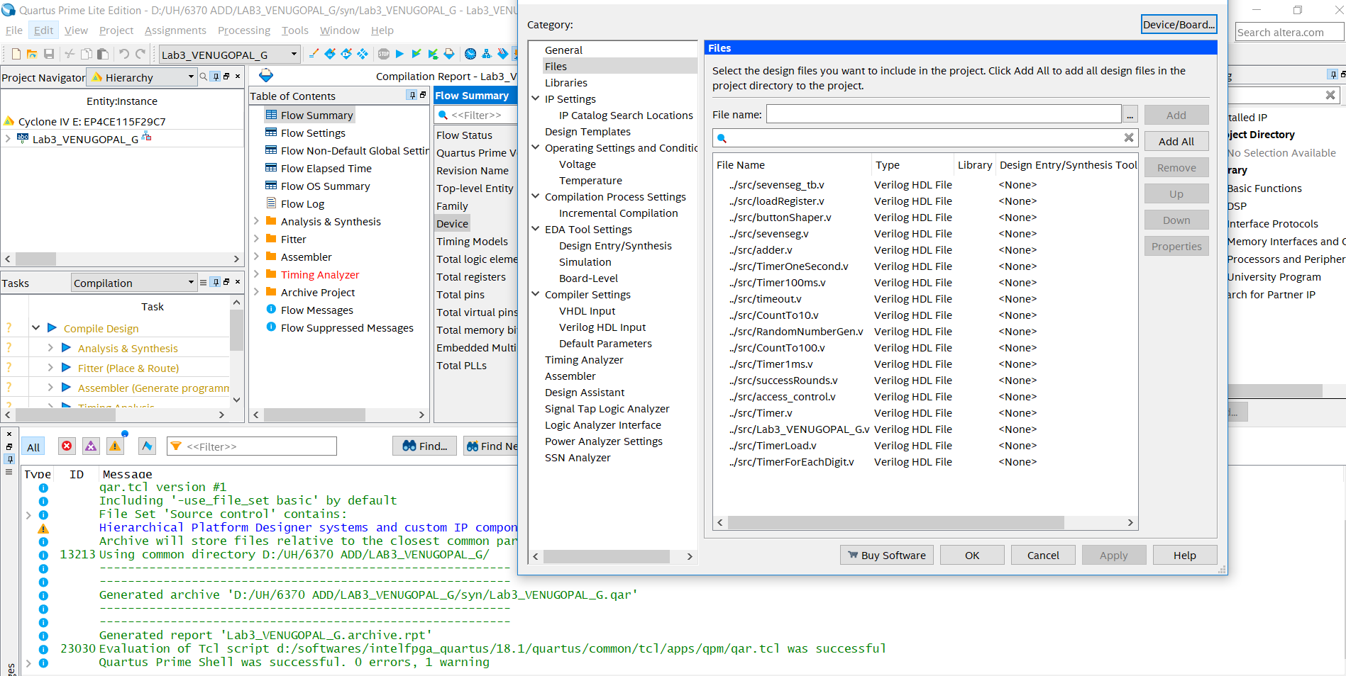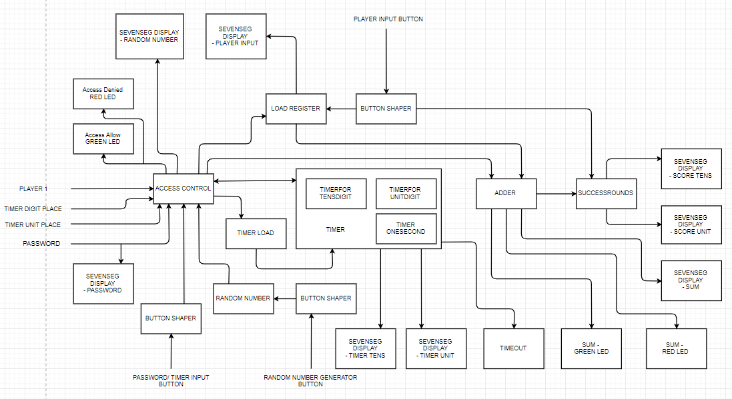

Figure 26: System Architecture. Names are altered for better understanding. Check modules section for exact module names.

Figure 27: Necessary Files are selected.

Screen shot removed since it had too many instance of my identity.

Figure 28: Compiling files in quartus. Status successful

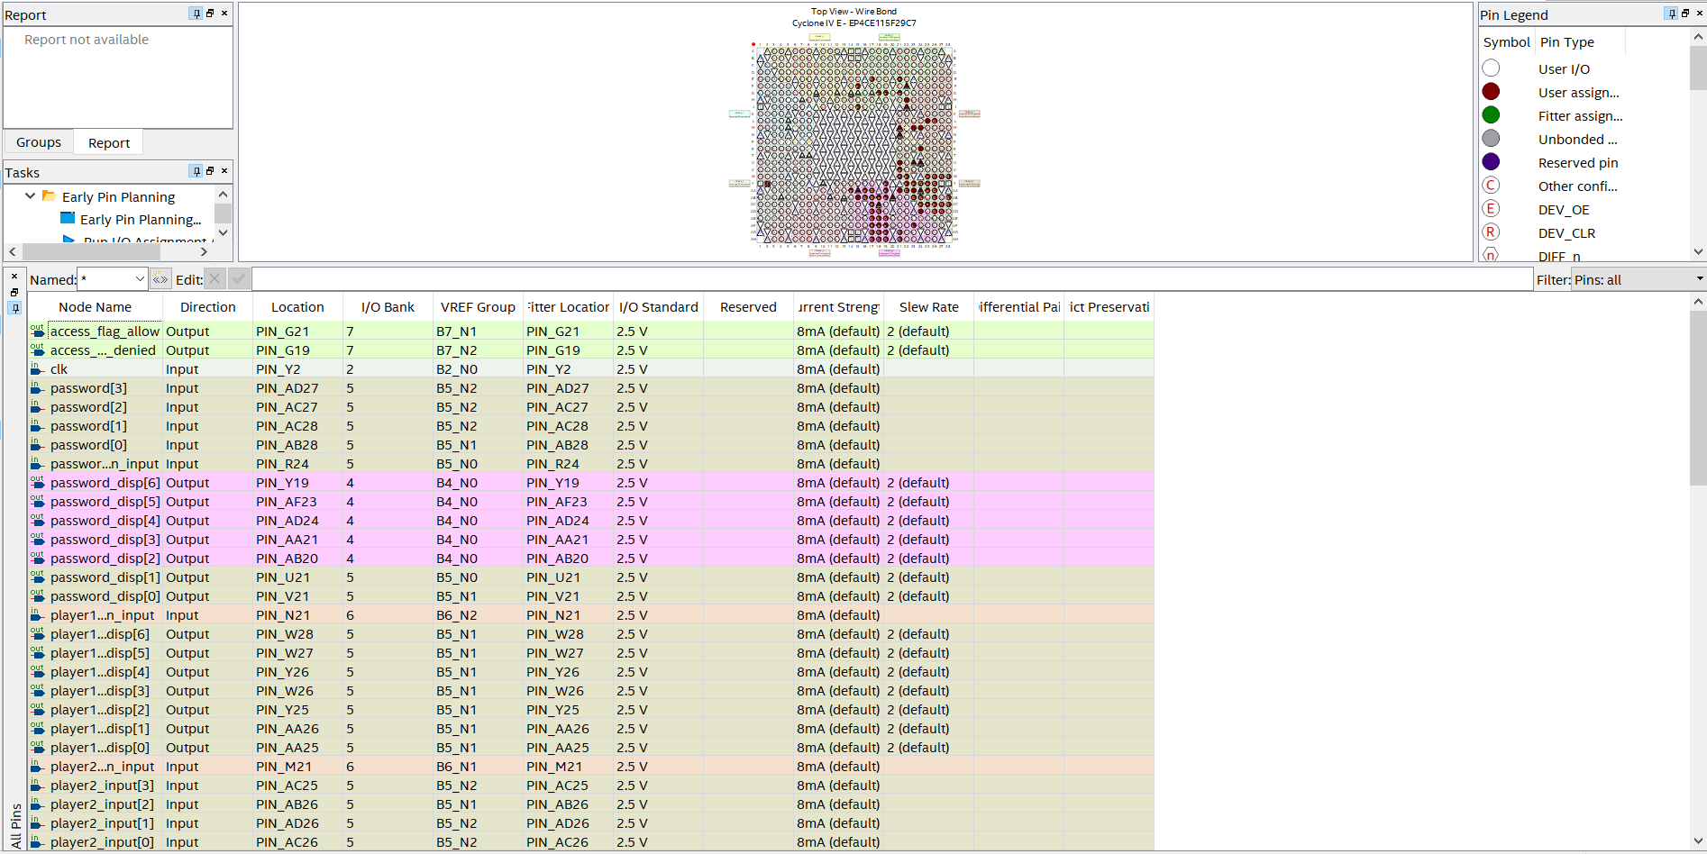

Figure 29: Pin assignment Completed

Screen shot removed since it had too many instance of my identity.

Figure 30: Project Archive in process

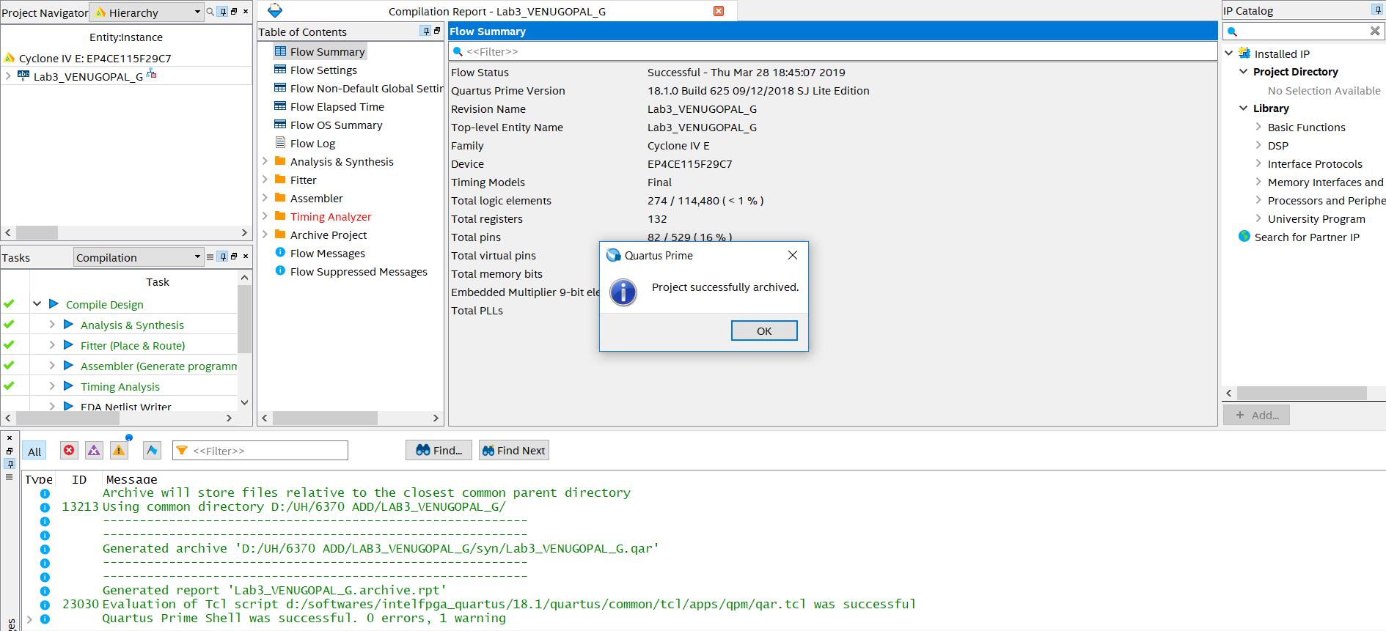

Figure 31: Archive successful

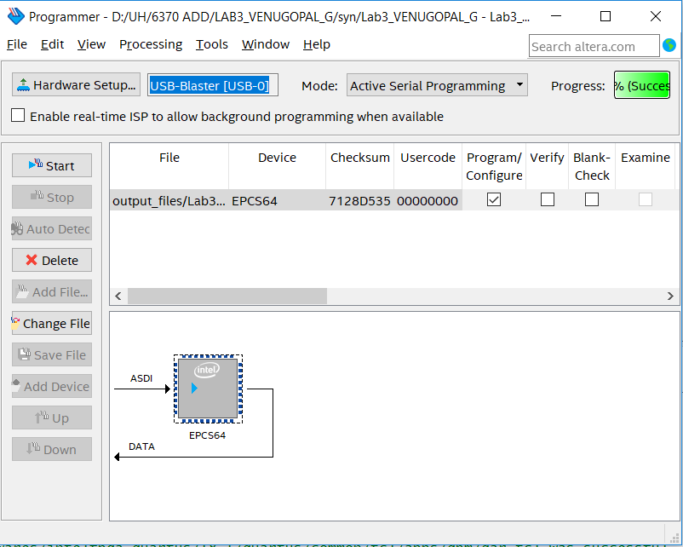

Figure 32: POF file is selected and compilation is completed.

# **SIMULATION**

## Access Control

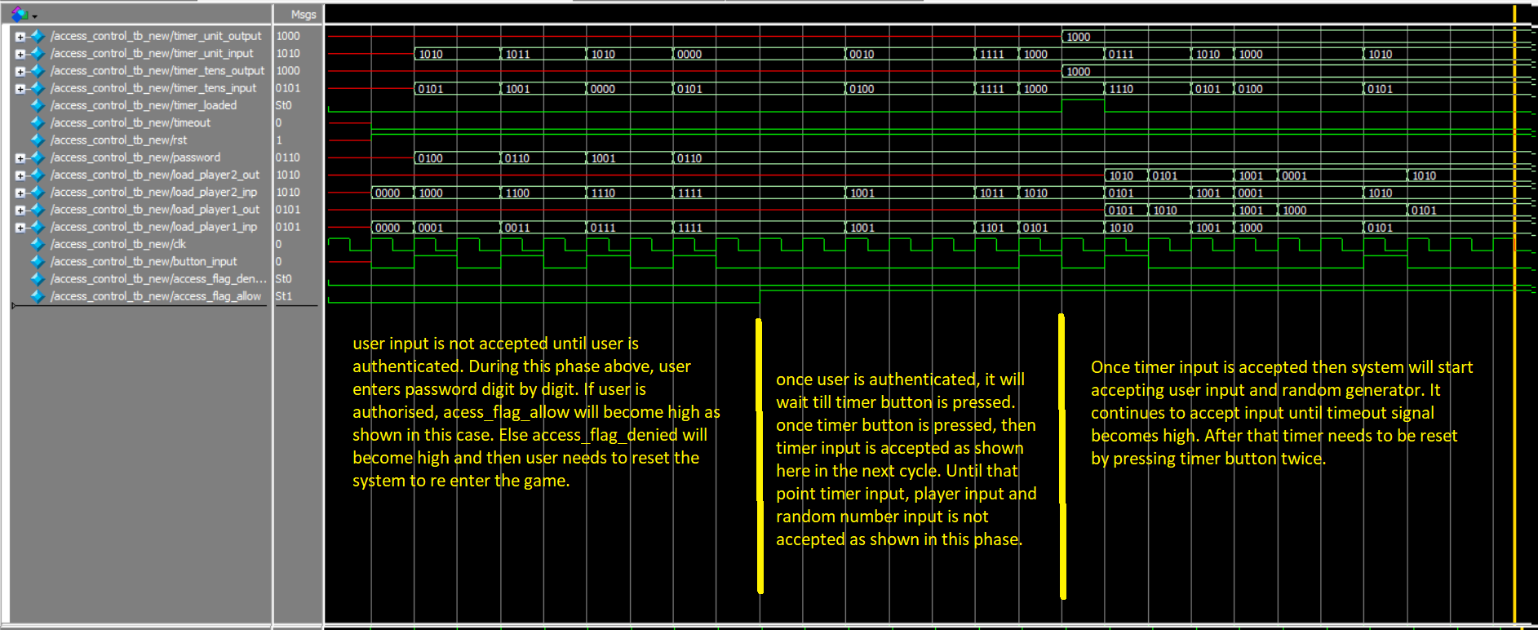Looking at the simulation, we can understand we can understand behavior of the access control. The output goes high when all four digits are correct and green led (shown by access_flag_allow) goes high. Also load register will show value when all digits are correct and timer is loaded by pressing password button. This is marked in the graph.

## Load Register

Looking at the simulation, we can understand the relation between the output and input bits. Output (count) shows value when reset is 1 and load is 1. During this period, value of output will be equal to input. i.e. output variable act as a register which gets loaded when load signal is high.

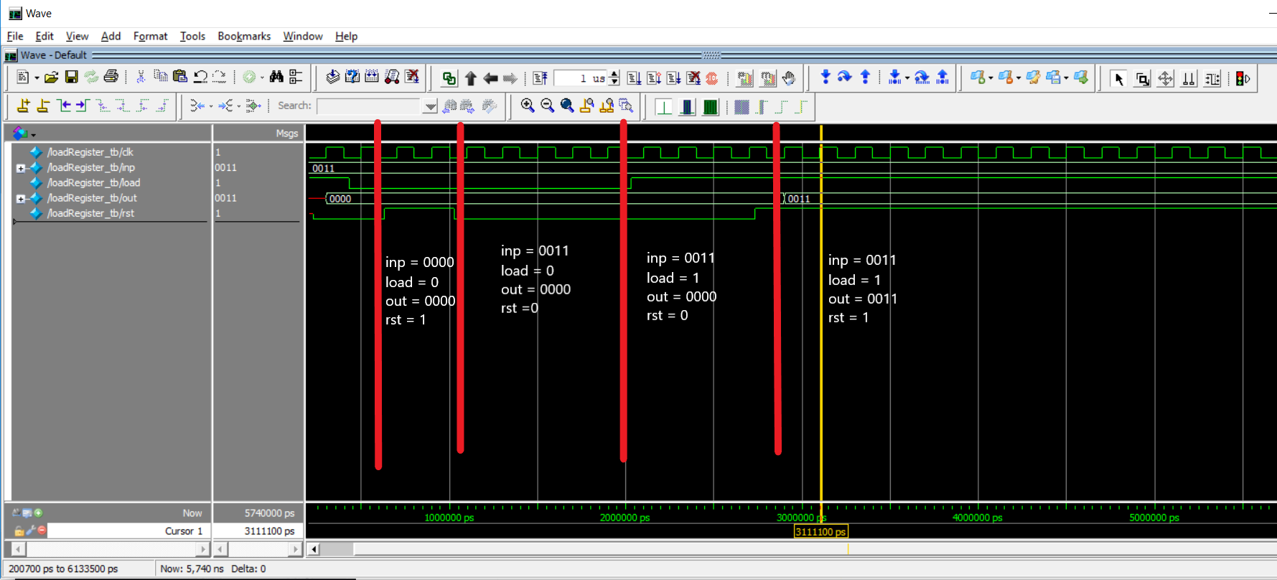

## Button Shaper

Looking at the simulation, we can understand we can understand behavior of the button shaper. The output goes high in the next clock cycle after button is pressed. This is marked in the graph.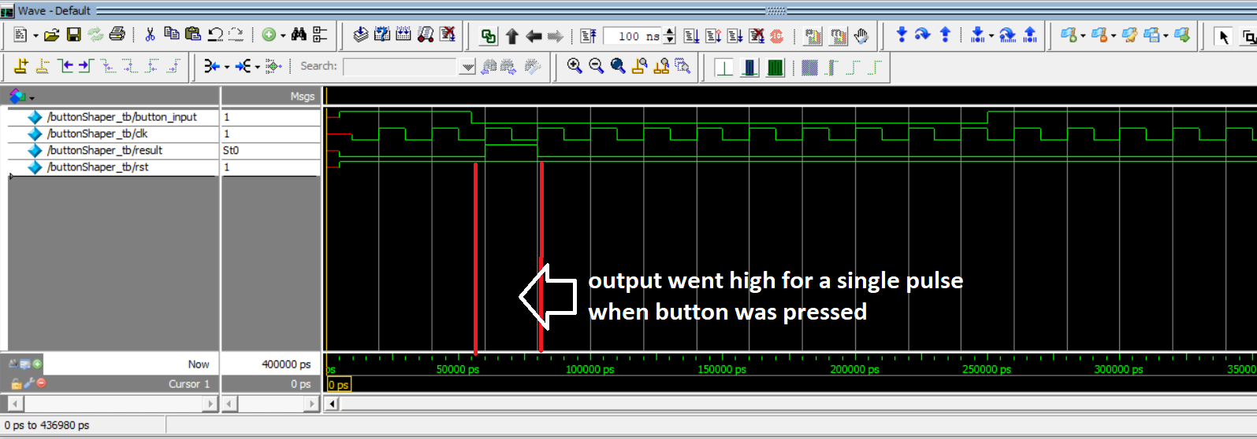

## Seven Segment

Looking at the simulation, we can understand the relation between the output and input bits. Output bits goes high according to the inputs bits that are high.

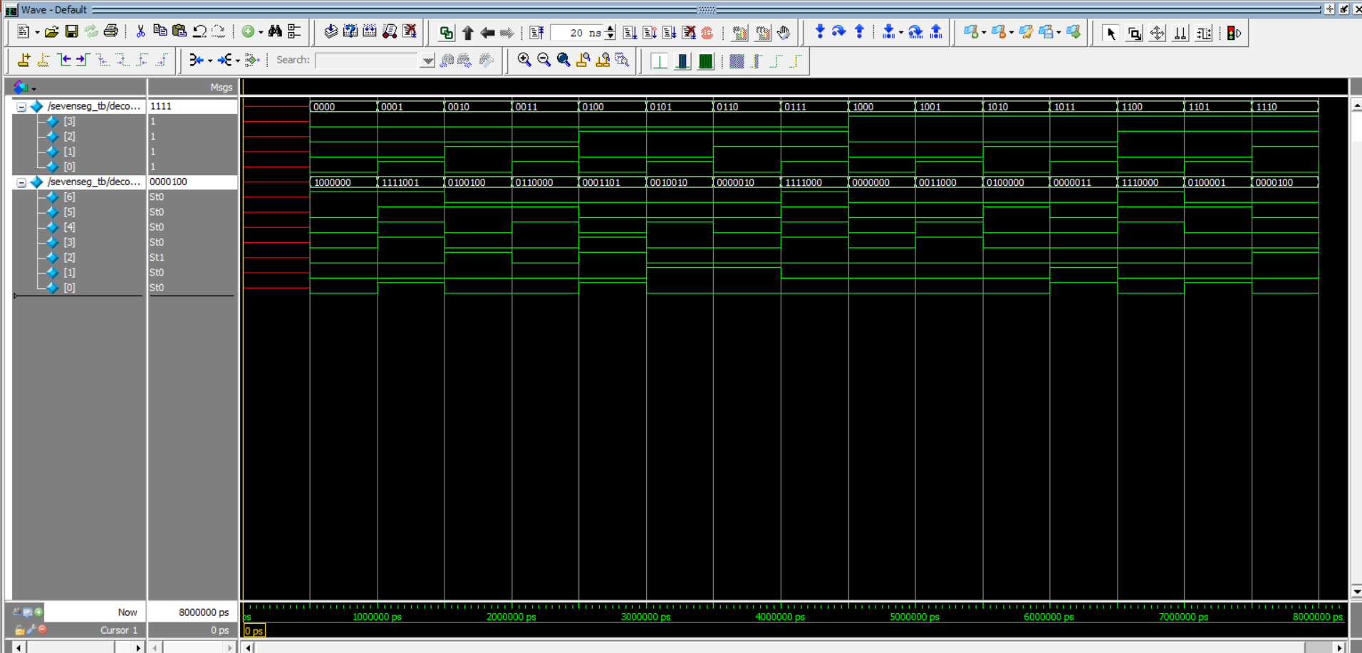

## Random Number Generator

Looking at the graph we can understand that a random number is generated as user presses the random number generator button input. The value of the number is equal to the number of clocks the button is pressed.

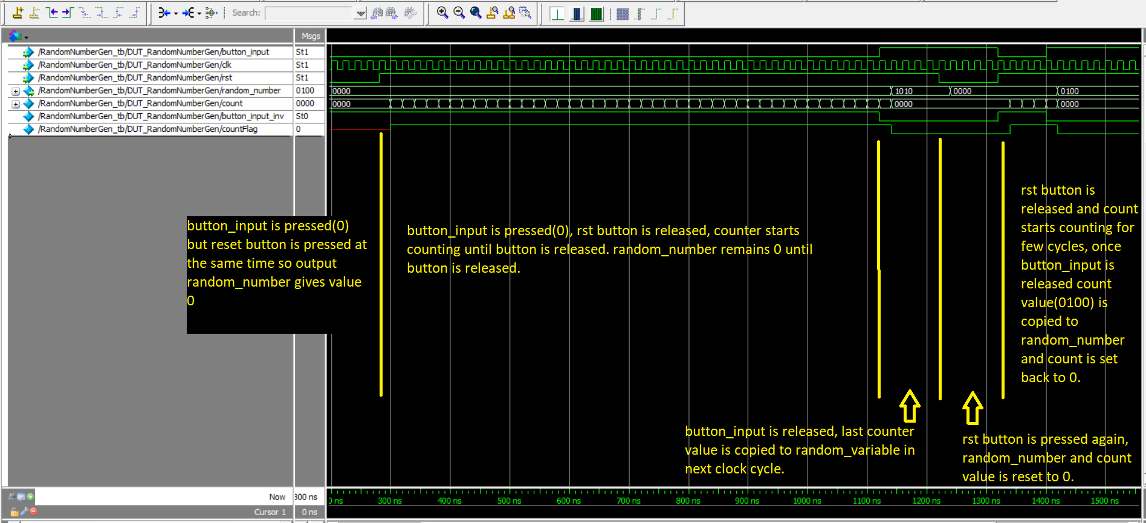

## Timer

As shown here, timer starts when timer load is high and starts counting when timer loaded is low. Once timer hits 0, a timeout signal is sent. This module uses countTo100 module to call timer100ms to get one second pulse. If it gets one second pulse, then timer value is decremented. Due to computational power restriction, timer 1 second was not executed. Instead time scaling has been done to receive similar result without waiting for 1 second simulation.

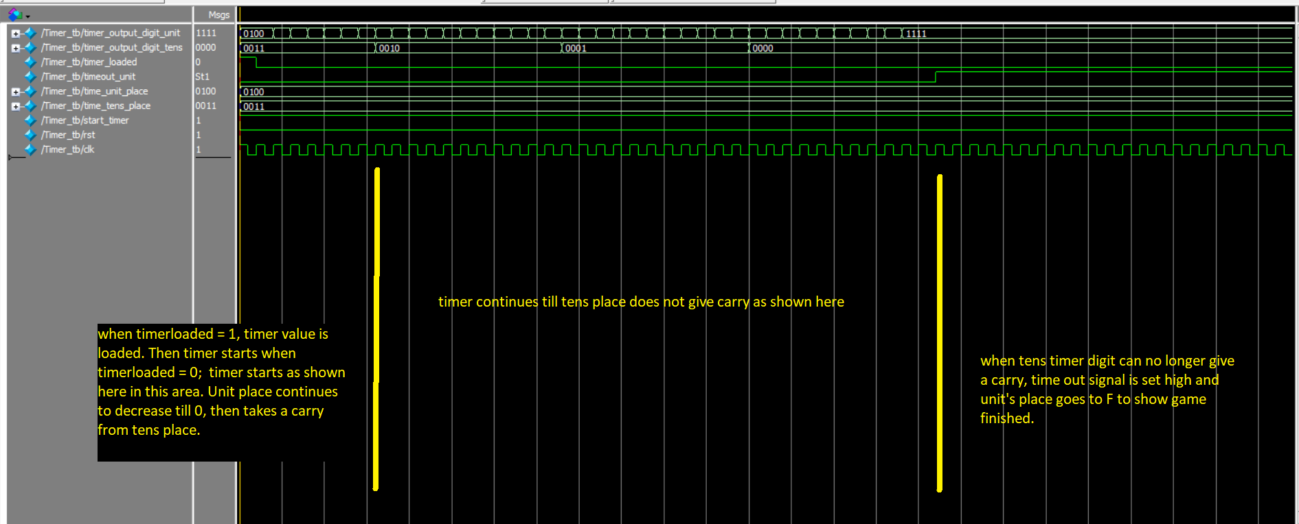

## Timer1ms

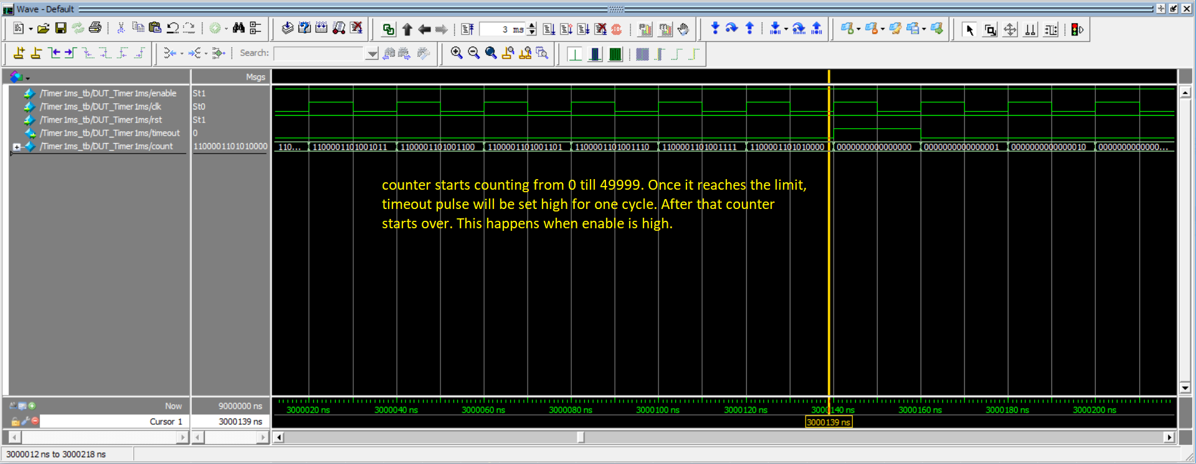As shown below, this module shoots a timeout signal when timer counts will 1ms.

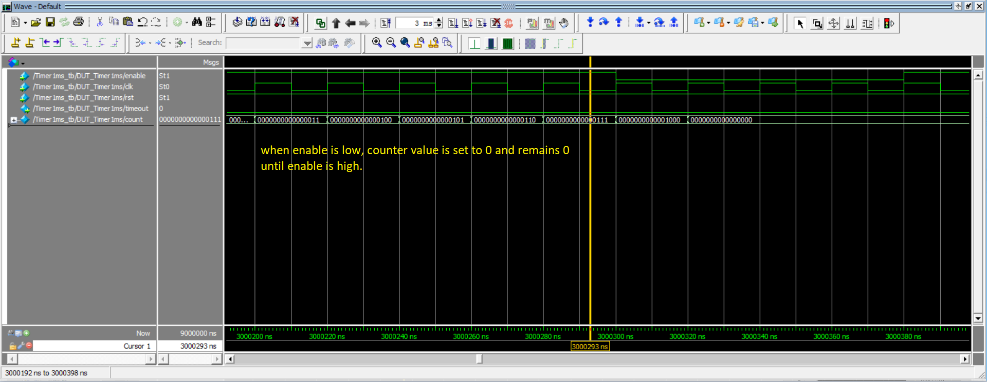

## Count To 100

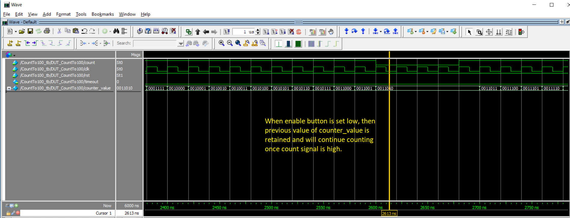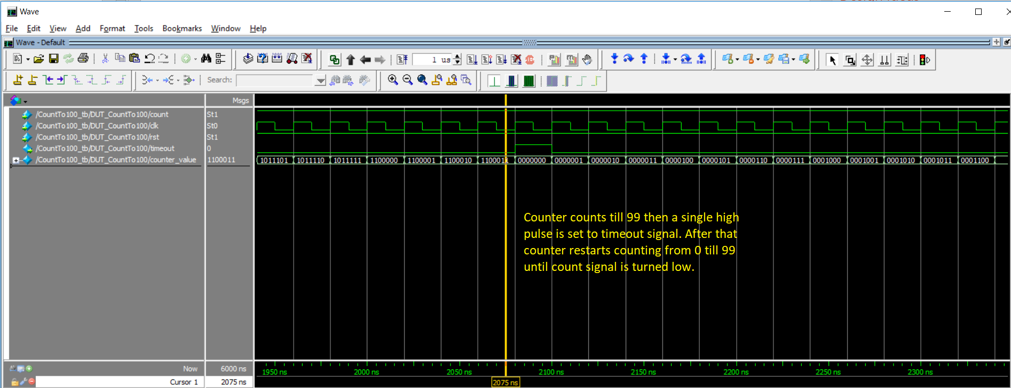This module as shown below, will generate a timeout when counter counts 100.

## Count To 10

This module shoots a timeout signal after executing for 10 times

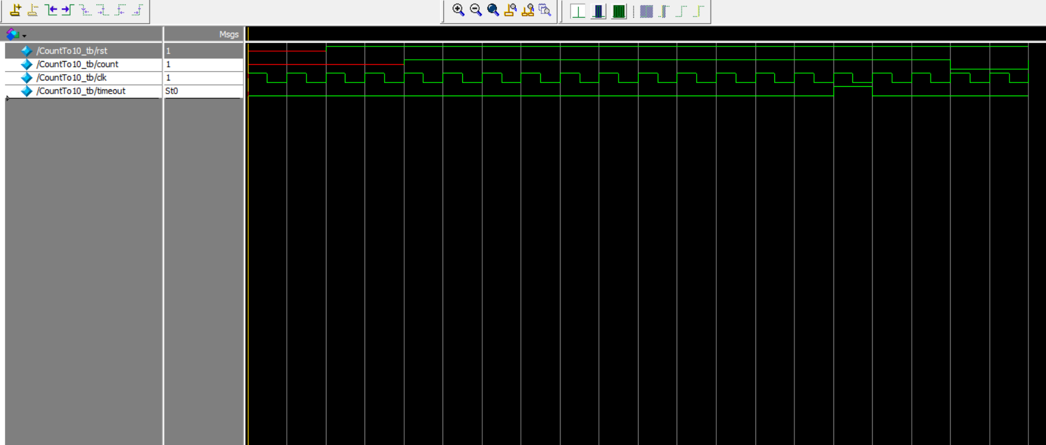

## successRounds

As shown here, score board increments if sum is 15.

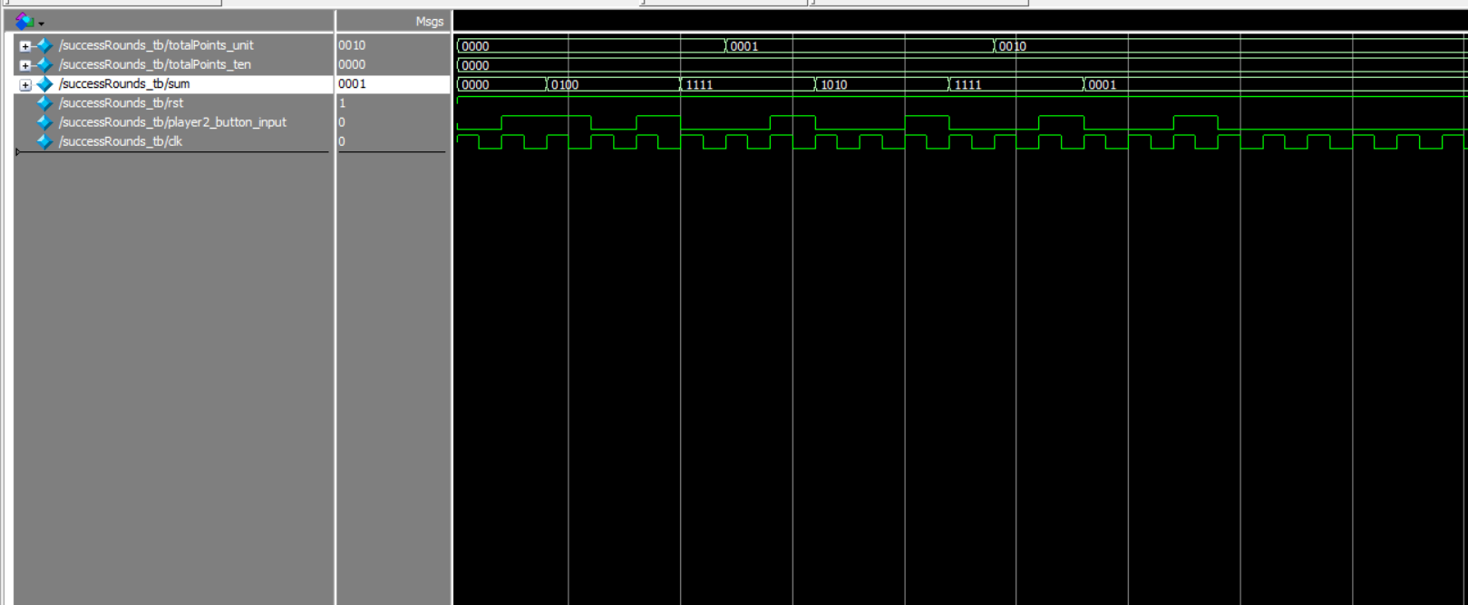

## LAB 3 Top Test Module

This module invokes other module to create game experience. During this period, it authenticates user, accepts timer period, accepts user input and checks for timeout signal to stop the process

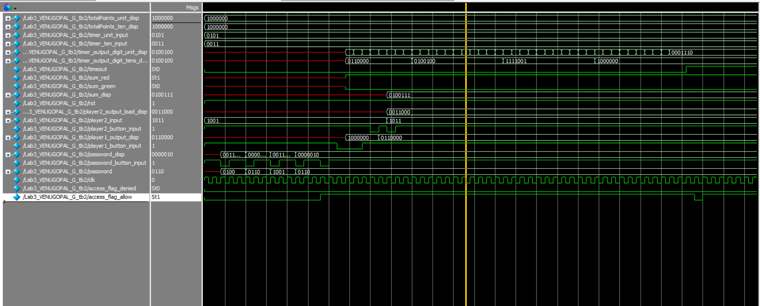

# **FPGA TESTING RESULT**

The above folder contains a single video explaining all modules and functionality of the game system.

First video talks about the layout of the board and how different input/output parameters are configured. Second video walks through how to play the game. First few seconds of the video shows how user enters password and authenticates himself. Once user is authenticated, green led glows up and then user must enter the timer. This is shown in the video by changing the timer switches and then hitting timer button. Then video proceeds to user generating a random number and then user inputs a value. User input, timer, random number, and sum is shown in 7 segments. Video shows multiple cases such as when user enters an input to sum 14 then another green LED lights up and score board increases. If sum is not 15 then a red LED glows an score board in not incremented. Video also shows how much is the max score a user can select that is 99. After that score resets to 0. Also, when timer hits 0, a timeout LED glows up and a F is shown. Video also shows how user must reset the system if he has entered a wrong password.

Lab3_4696

1. First logging in functionality was tested. For this board was turned on. Picture of this state shown in Figure 33. 4-digit password was entered in 4-bit binary form using password input toggles switches shown in Figure 34. Once user logged in Green LED near password button glow up as shown in figure 35.
2. User sets the time and hits timer/password button to start timer and enter game.
3. User can generate random number as shown in Figure 35.
4. User then has to enter a input sum such that the sum is 15. But in Figure 36, we can see that user has failed to get a sum of 15. Then a red LED is shown 38
5. User can select another value to get a sum of 15 as shown 39.
6. User can play again to score another point as shown in Figure 40.
7. Eventhen user can only score a maximum of 99 after that it resets to 0.
8. When timer goes 0, a timeout LED is lit up and F is shown in display as shown in 44.
9. To enter again user has to reset the timer as shown in Figure 43.
10. If user has not been authenticated, the RED Led glows. Then user must press reset to enter back.

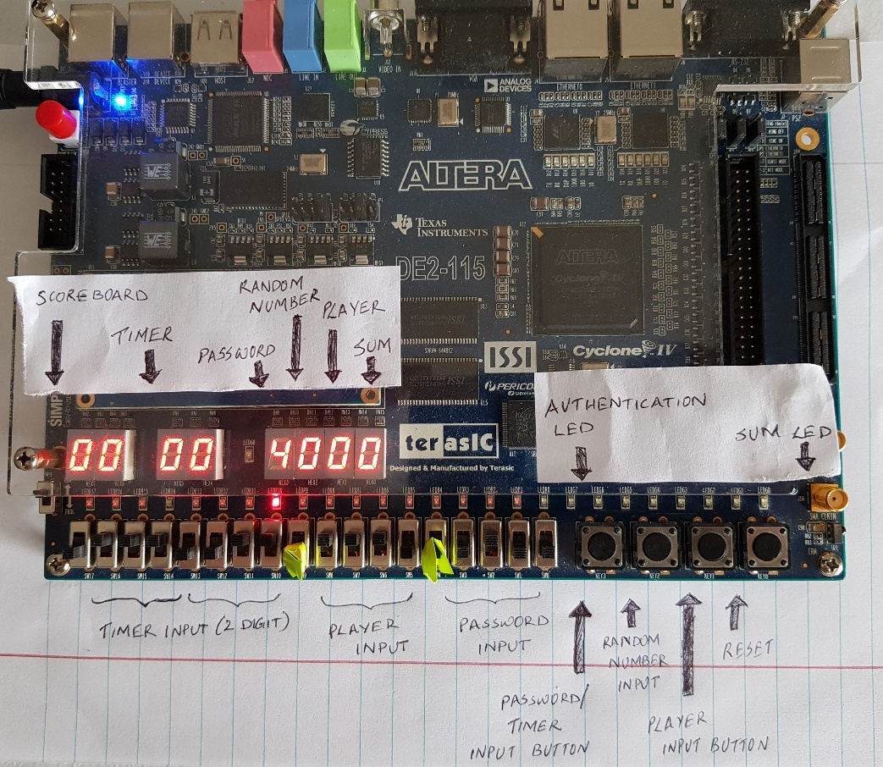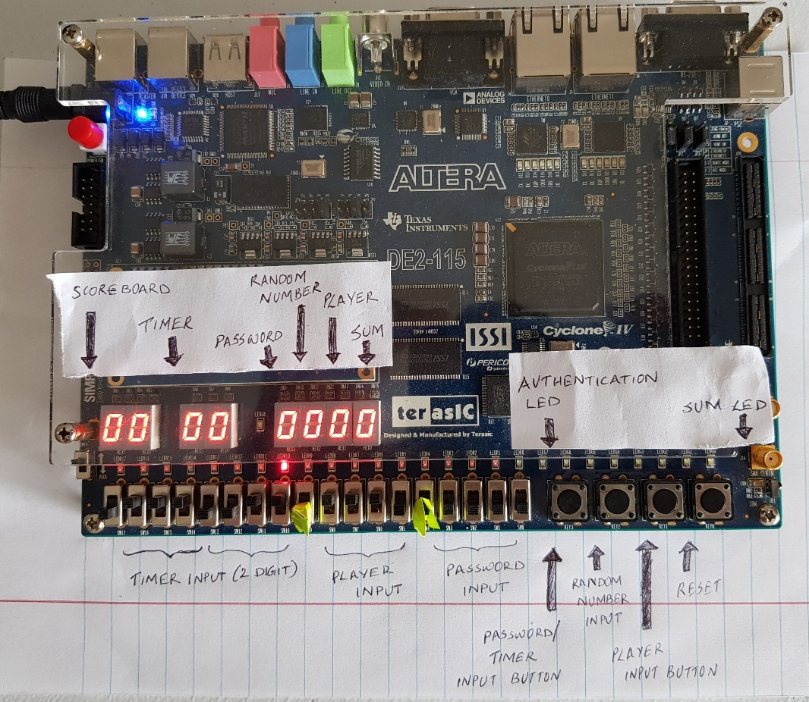

Figure 33: Default/Initial state

Figure 34: Player started entering password. A set of 4 digits need to be entered for authentication.

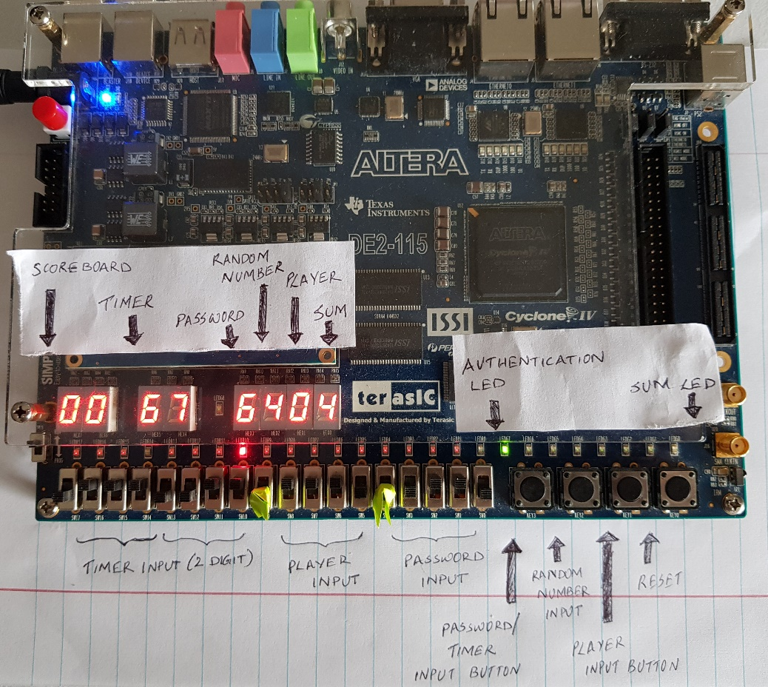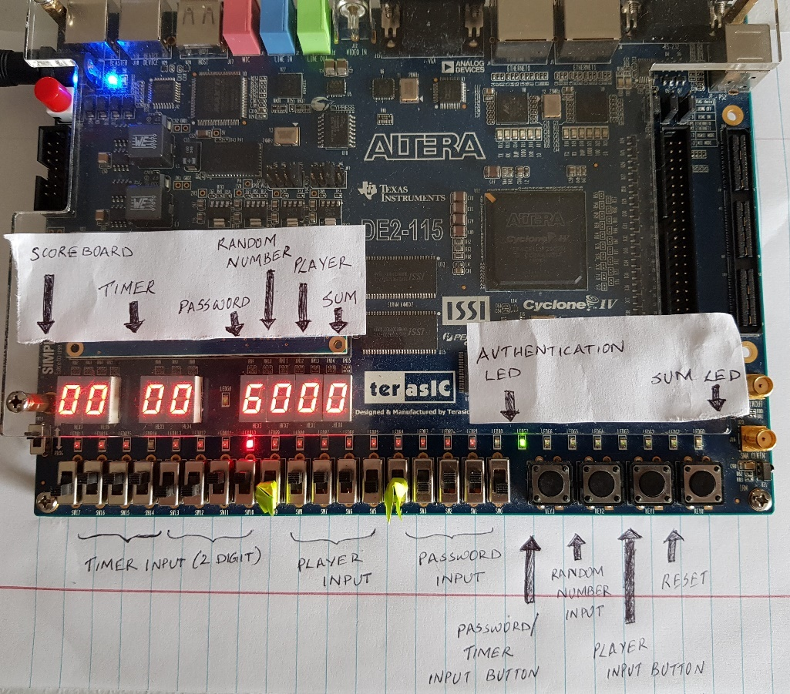

Figure 35: User set timer value by hitting password button and generated a random number by pressing random number input button

Figure 36: User entered right password indicated by authorization GREEN LED.

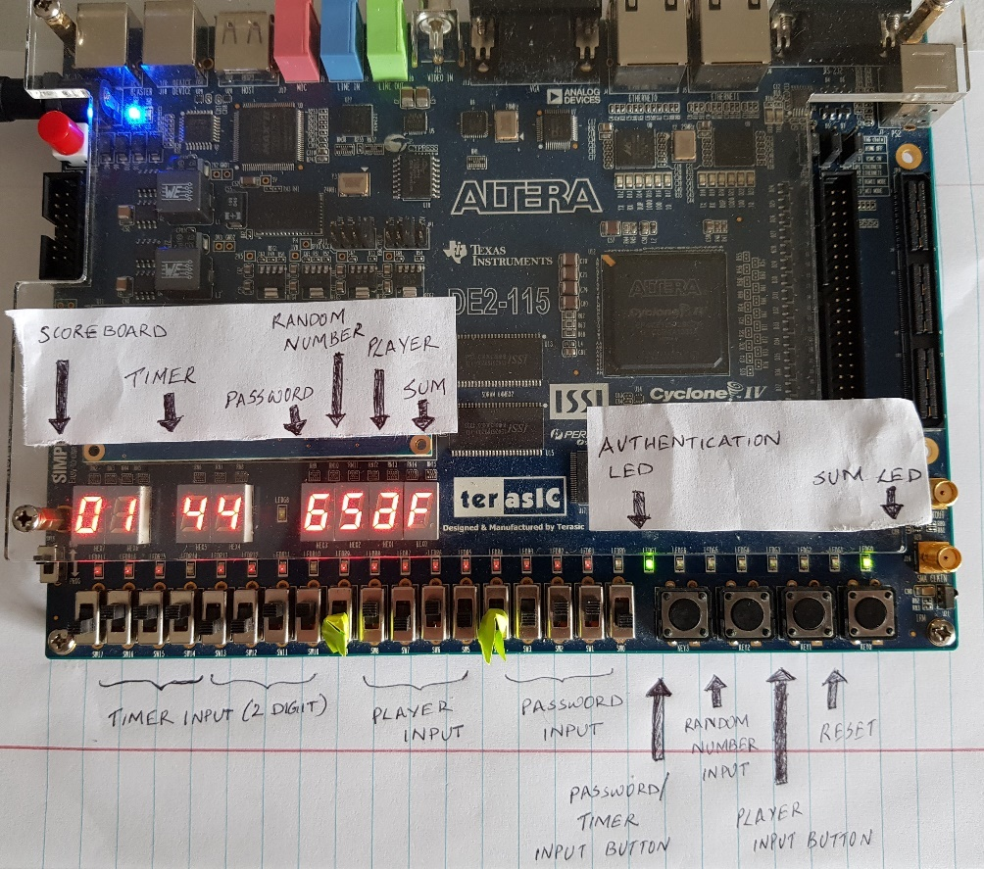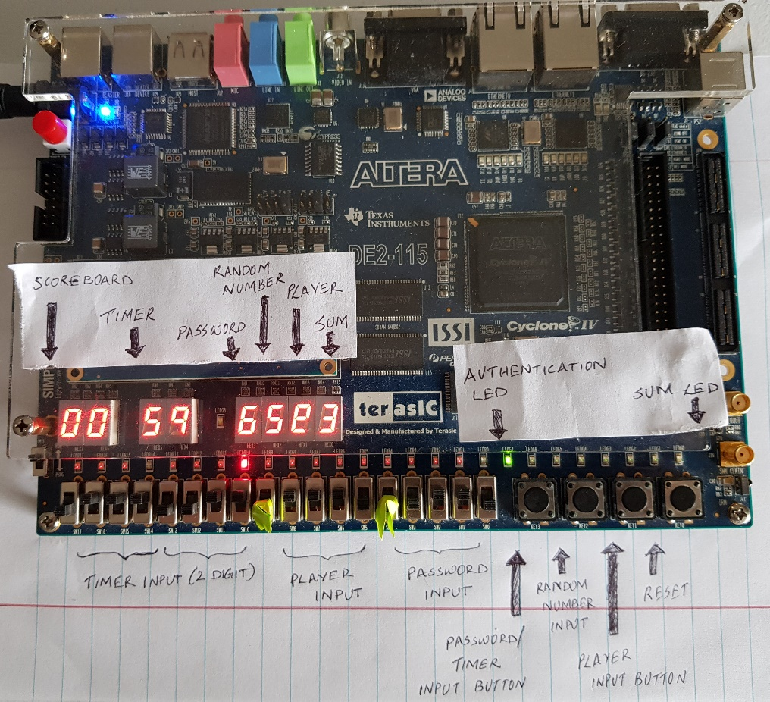

Figure 37: User enters a value that makes sum 15. Sum is displayed on seven segments. Green led is lit up to show sum is 15. Score board increases by 1.

Figure 38: User enters a value to get a sum of 15 but did not reach 15. Sum is displayed and red led is lit up to show sum is not 15.

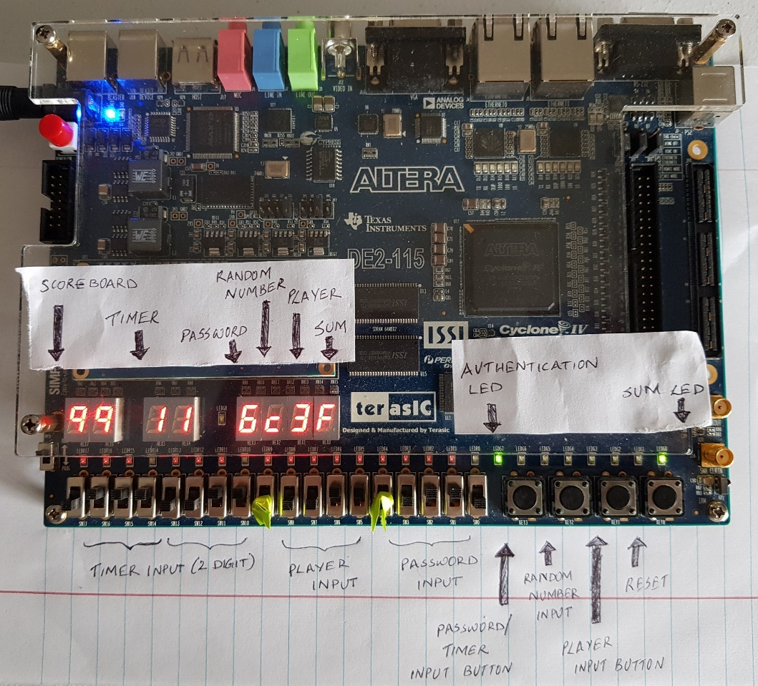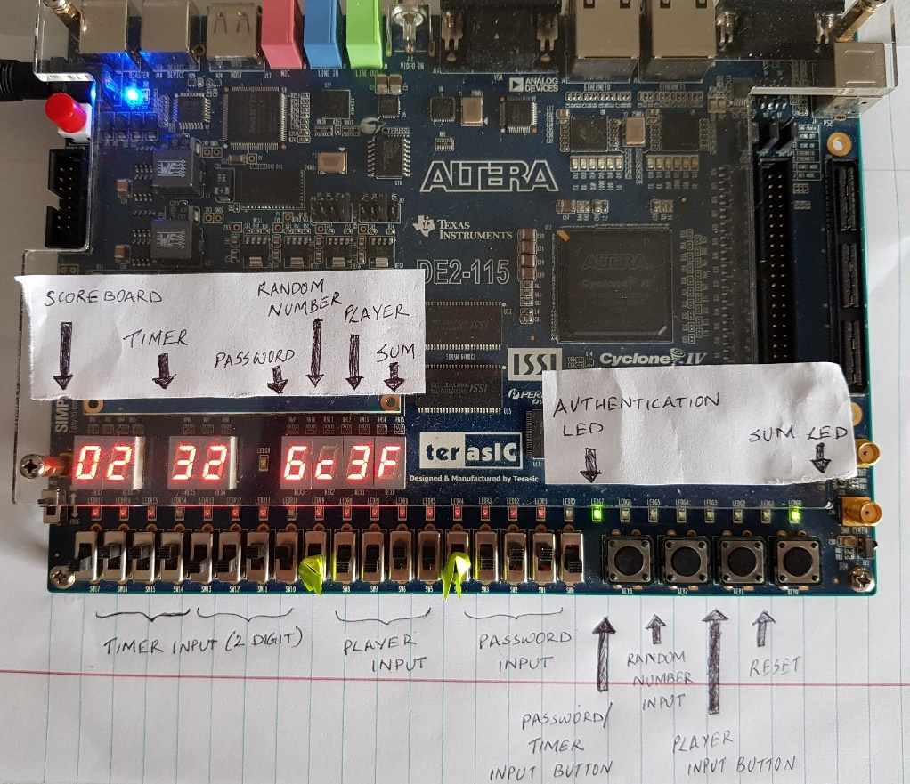

Figure 39: User reached maximum score of 99. Score board resets to 00 after this.

Figure 40: User generates another score indicated by incremented score count.

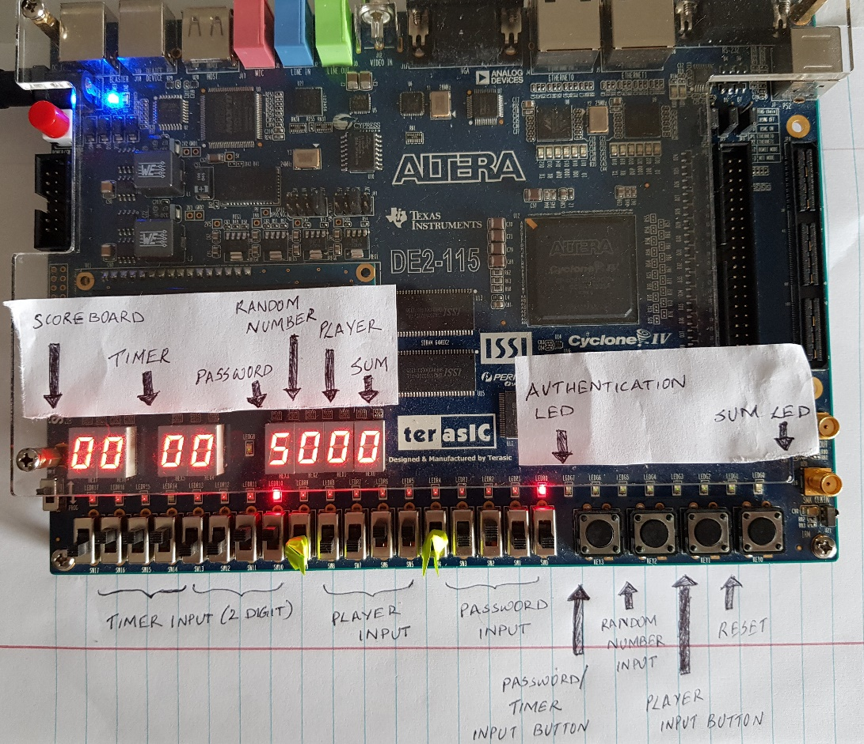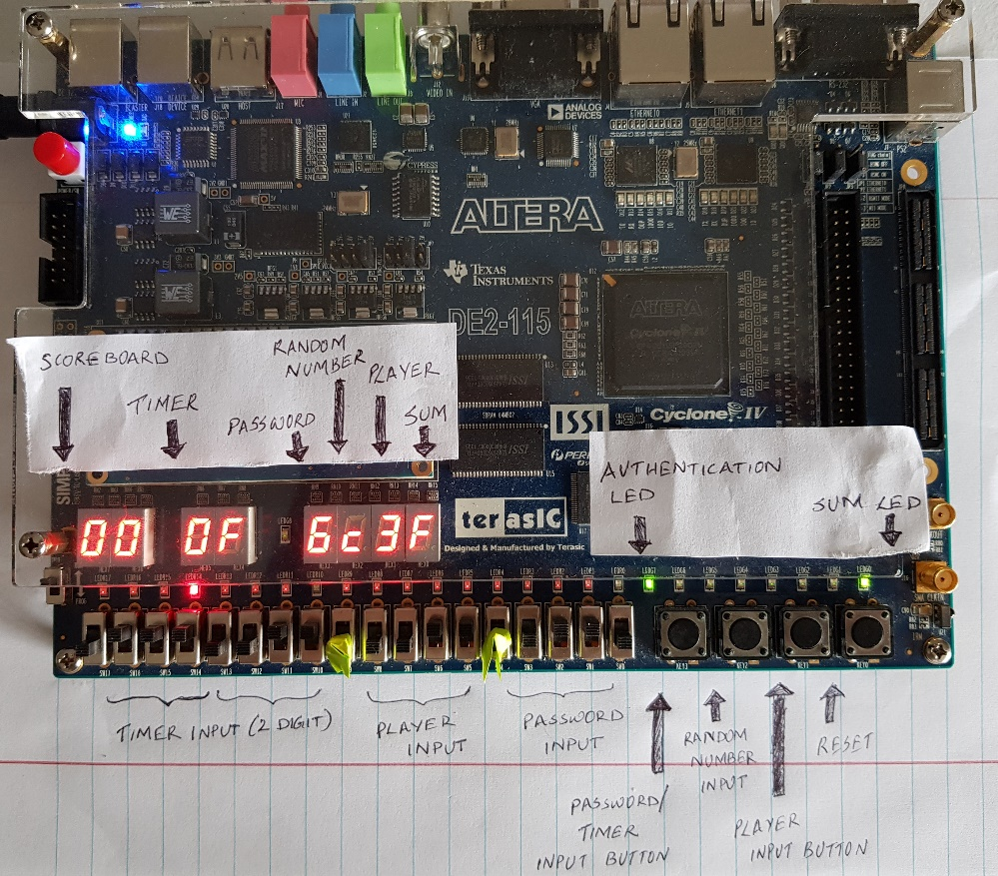

Figure 41: User resets the system to clear everything

Figure 42: Timer reached 0. This is shown by F in timer display to indicate game finished and another RED LED is lit up

# **Conclusion**

This activity was to understand the design and working of game control. While doing activity, I was able to understand how the knowledge on timer, score counter, 7 segment display, access control, adder, button shaper and load register can be used in a real-life scenario like a game. I have also implemented bonus feature score counter using separate module and has tested this feature successfully. I have been able to complete this homework without any error and simulate the graph properly.

# Appendix